Profile Analysis

**Description:**

Profile analysis is the multivariate version of a repeated measures analysis. Generally profile analysis is used for multivariate mixed designs with at least one between subjects variable and one repeated measure variable. Profile analysis combines the dependent variables (here the time measurements of repeated measures) to examine if there are differences in the over “profile” for your different groups.

**Definitions/Abbreviations:**

Between subjects – between subjects variables are used here for independent variables. Between subjects variables are variables with different groups or labels and cannot have continuous values. MANOVA is a between subjects ANOVA with several dependent variables.

Repeated measures – repeated measures variables are different dependent measures tested on the same people. They can be measured over time or several scales taken at the same time from the same people.

DV combinations – Wilk’s Lambda, Roy’s Largest Root, Hotellings Trace, Pillia’s – these are all listed in the multivariate test. They are different ways to combine the DVs in such a way that creates large group differences on your IVs. The most commonly used is Wilk’s Lamba.

Levels – main effect analysis for your between subjects variable. This test tells you if there are overall group differences on the profile or all the repeated measures variables combined.

Flatness – main effect analysis for your repeated measures variable. This test tells you if there are differences in the different repeated measurements regardless of group.

Parallelism – interaction analysis for the relationship between your repeated measures and between subjects variables. This test tells you if there are different patterns of profiles for different groups across time.

**Power:**

You want to check how many people you need to run (or alternatively, how many more people you need in a study).

Using G*Power, finding ideal participant numbers is fairly easy. Set up options:

* Test family: F-tests
* Statistical Test: MANOVA: Between-Within Interaction.
* Type of power analysis: A priori (most common)
* Effect size f: either guess at an effect size based on research, use a small effect size for good measure, or after a couple subjects run a prelim test and use the current effect size. (You can click determine to convert eta squared to f).
* Alpha = .05
* Power = .80
* Number of groups = Between subjects, how many groups
* Number of measurements = repeated measures, how many time or scale measurements.

Hit calculate for the number of participants needed.

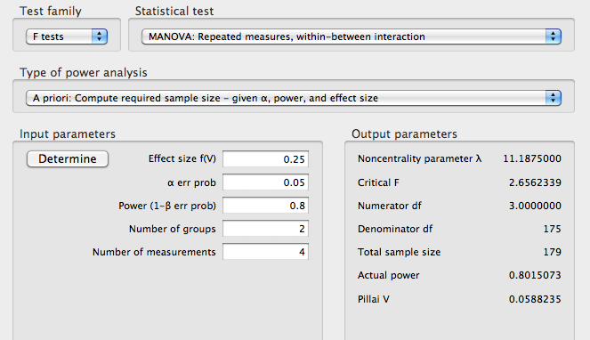

**Assumptions:**

Missing data: missing data will completely eliminate a person from this analysis. You want to check for missing points and determine what type of replacement you want to use (if any). You might also consider HLM if there are large numbers of missing data.

Outliers:

* Univariate – outliers only on the DV. You want to check z-scores for people who are more than 3 (3 or -3) away from the mean. This analysis will check each DV separately.
* Multivariate – outliers on the combination of the repeated measurements. This procedure uses Mahalanobis distance to make sure that people do not have a strange combination of answers all of the repeated variables.
  + You can do both of these or just Mahalanobis. You may not want to eliminate people who are a univariate outlier on one variable, but you really should eliminate people who are multivariate outliers (especially since this test is multivariate!)

Multicollinearity: You want to check your RM measurements by using a correlation to make sure they do not overlap too much. You expect them to be correlated, but it will not run if you use variables that are exactly the same. Look for variables with r>.99.

Linearity: Linearity between the RM measurements is a very important issue because the combinations made of the giant DV are linear. You can check for this value using a fake regression or bivariate scatterplot.

Normality:

* Univariate – you want RM measurements to be normally distributed by themselves. You can check this information through frequencies and asking for a histogram. Non-normal distributions also have skew and kurtosis values over 3/-3.
* Multivariate – you also want the RM combinations to be normally distributed. You can check for multivariate normality by running a fake regression and asking for a histogram of the residuals.

Homogeneity: the variance of the groups from your BN variable need to be equal across all of the RM measurements. You can check this information with a residual plot from your fake regression (you do not want raining or an unequal spread of the dots around 0). You can also use Box’s M test of homogeneity – you *do not* want p<.001.

# Complete Example

**IV(s):**

Agemate – a between subjects variable that groups children into three categories (1) prefers playmates that are younger then them, (2) prefers playmates that are older than them, (3) prefers playmates that are their age or no preference.

WISC – Children’s intelligence scale, repeated measure variable because children get all subscales of the WISC.

* Info: information
* Comp: comprehension
* Arith: arithmetic
* Simil: similarities
* Vocab: vocabulary
* Digit: digit span
* Pictcomp: picture completion
* Parang: picture arrangement
* Block: block design
* Object: object assembly
* Coding

**Research Questions:**

Flatness: Are there different scores on the WISC subscales regardless of choice of playmate? (repeated measures factor)

Levels: Do the different choices in playmates affect overall WISC profile scores? (between subjects factor)

Parallelism: Are there different profiles on the WISC subscales based on choice of playmate? (interaction)

**Assumption Checks:**

Missing Data

1. You want to screen the data for any missing time points. You will have to decide if you want to fill in that time point based on the average from everyone at that time point or the average between two points for that person.
2. If you have a lot of people, it’s easier to eliminate them.
3. If you are working with very few subjects, a hierarchical linear model would be more appropriate because HLM does special imputation for missing data for time series type designs.
4. To check for missing data you can just scan the dataset or run a descriptives to get a quick visual of where the data is missing.
5. Analyze > Descriptive Statistics > Frequencies:

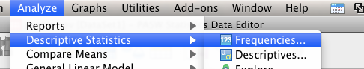

1. Move ALL the variables over to the right side.

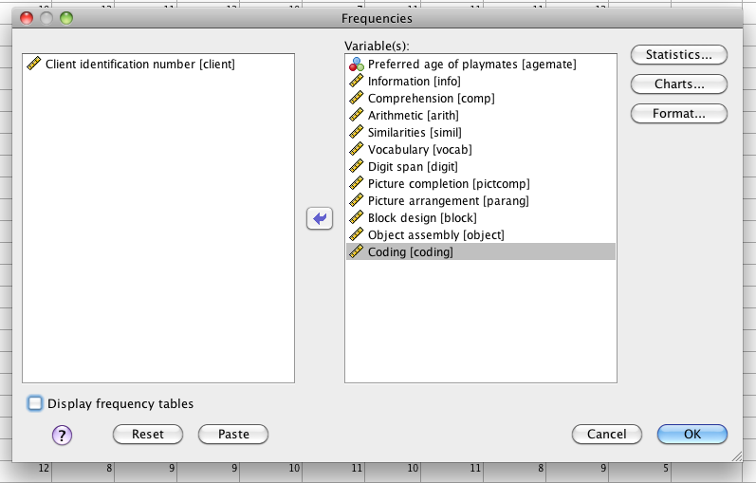

Note: I’ve turned off frequency charts because I also asked for histograms. You can use a frequency chart for between subjects IVs to see how many people are in each group.

1. Hit charts to get univariate normality histograms. Select Histogram and Normal Curve.

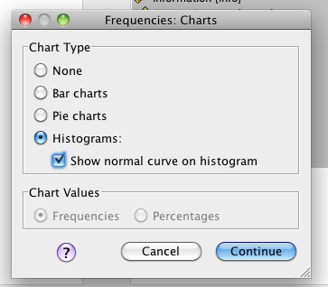

1. Missing data: Look at the table of values. It gives me “valid” and “missing”. I can see here that my between subjects IV is missing 9 people, and my comprehension variable is missing 2 people.
   1. You do NOT usually want to fill in between subjects IVs because they are groups/categories. You can go back and find out what type of playmate the child preferred, but it’s not a good idea to guess.
   2. For the missing data in repeated measures variables, the most common method is to mean replace with the mean of the series. That means that those two scores will get filled in with the mean of COMPREHENSION and not the mean for the person.
   3. For designs that are “time based”, you would be better off filling in the data with the average (or linear trend) for the person, not the time measurement. Usually people average Time 1 and Time 3 to replace Time 2, because that’s better suited for the person (and keeps the variance for that person relatively stable).

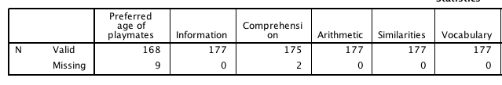

1. BEFORE you take the next step, decide what to do about missing data because it will change the next analyses.
2. One type of replacement is *linear trend at point*.
3. Transform > replace missing values.

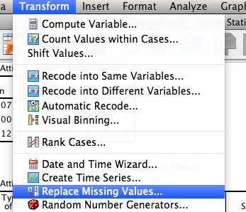

1. Pick Linear trend at point *before* you do anything else.

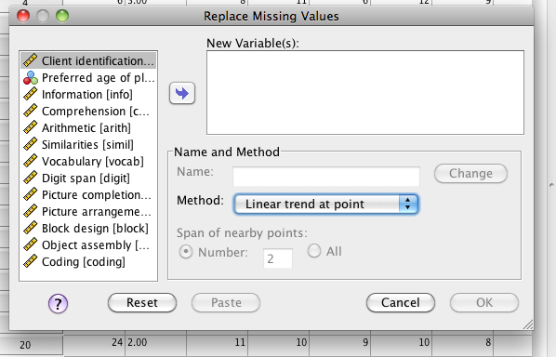

1. Move over the variables you want to replace missing values on and hit ok.

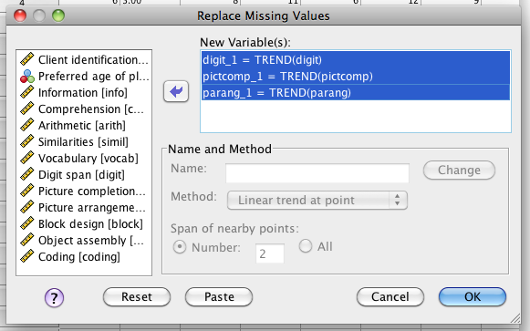

Outliers

1. Univariate outliers: to check for univariate outliers, you want to use z-scores and nothing above or below 3 (3 or -3).
2. Analyze > Descriptive Statistics > Descriptives

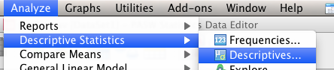

1. Move over your repeated measures variables (you cannot be an outlier on category between subjects variables).

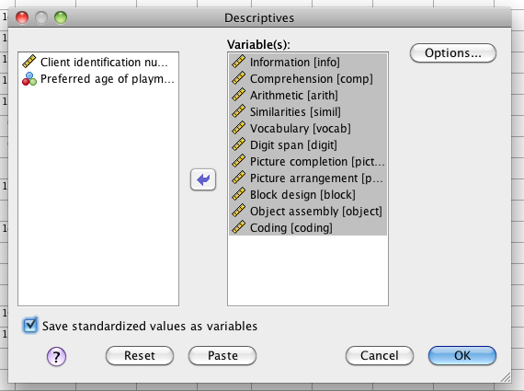

1. Be sure to hit “save standardized values as variables”. This checkbox will give you the zscores. Hit ok.
2. Now, there are a LOT of time measurements. You can sit and sort each one individually looking for high and low above 3 values. Or you can ask for min and max values.
3. Analyze > Descriptive Statistics > Frequencies (see above).
4. Move your repeated measures z-scores to the right hand side. Hit statistics.

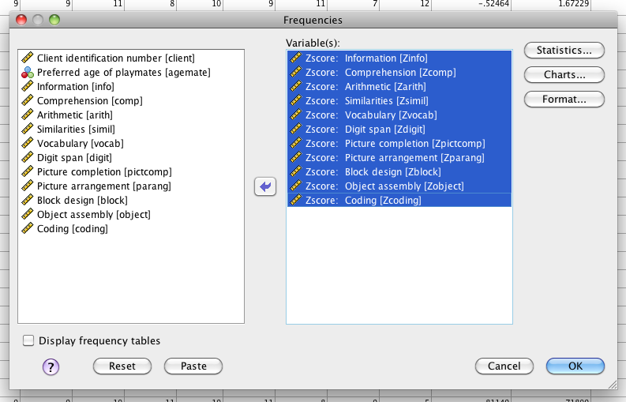

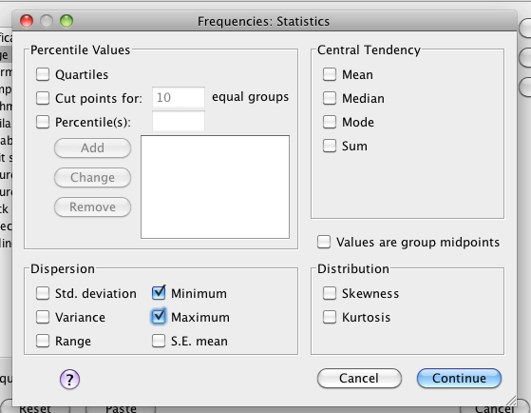

1. Ask for the minimum and the maximum. Hit continue and ok.
2. In the output you are looking for any variable with a z-score greater than 3.
3. Here information and arithmetic have z-scores in the univariate outlier range.

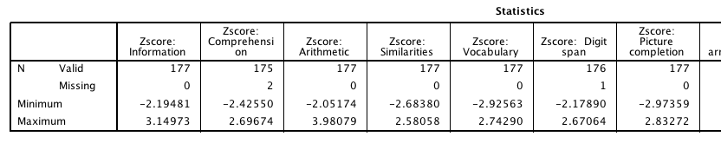

1. So what do you do?
   1. You can eliminate them.
   2. You can move them to the end of the distribution (squish).
   3. You can estimate them as if they were missing.
   4. You can wait and see if they are multivariate outliers, then decide.
2. Multivariate outliers: if subjects are multivariate outliers, you have several options.
   1. Eliminate them completely (most common).
   2. Run the analysis with and without to see if they make a difference.
   3. Look at your univariate outliers and see if ONE of the repeated measures variables is the reason they are a problem. Fix that one variable and try again.
3. First, you want to create a random variable for your fake regression to get Mahalanobis values.
4. Transform > compute variable.

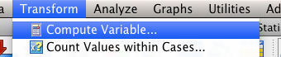

1. Call the variable something that you will remember later means it’s fake (like random). Select random numbers from the options on the right hand side. Use a random operator to create your random variable (I use ChiSq). If there are ? marks that means you need to pick a number to use to create the random chi square value. I just picked object to create the value from. Other random functions want different values.
2. Now that we have a random variable, you will want to run a “fake regression”.
   1. Analyze > Regression > Linear.

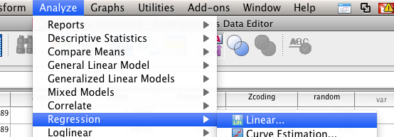

* 1. Put your random variable in the Dependent box.
  2. Put your repeated measures variables in the independent box.

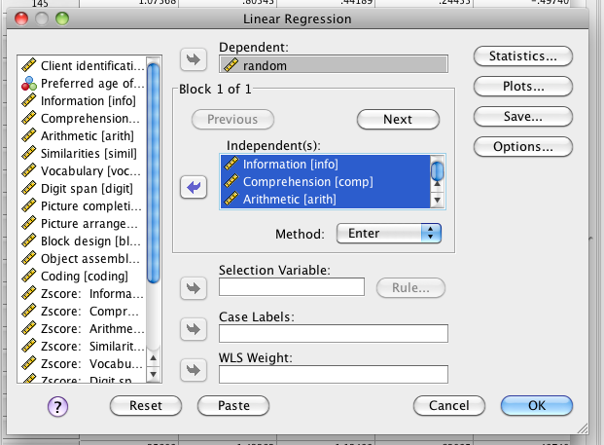

* 1. Hit plots. Put zpred in the Y: box. Put zresid in the X: box. Hit the checkboxes for histogram and normal probability plot. Hit continue.

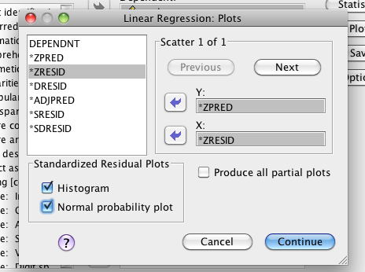

* 1. Click save. Hit the checkbox for Mahalanobis.
  2. Hit continue and save.

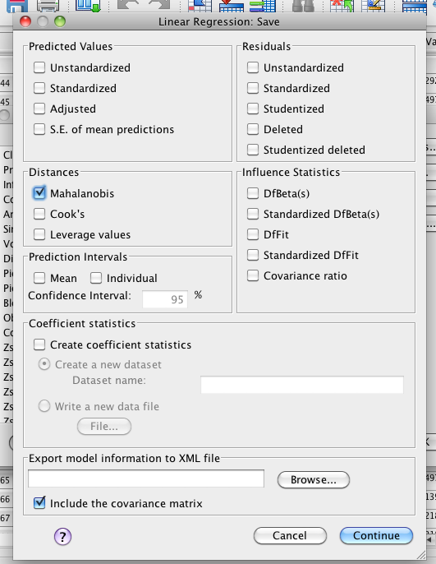

* 1. Go to the Mahalanobis column that was created in your dataset.
  2. Sort the column descending (right click > sort descending).

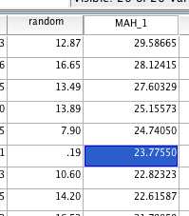

* 1. Figure out the cut off score for Mahalanobis. You will want to use a Chi-Square table for cut off scores. Degrees of Freedom are the number of variables (here we have 11 repeated measures time points). You will use the p<.001 value for cut off scores. This example has a cut off score of 31.26. Therefore, none of the people in this dataset are outliers (because the highest score is 29.58).
  2. If you have univariate outliers that are not corresponding multivariate outliers, a lot of people leave the univariate outliers alone because their *combination* of scores is not unusual.

Multicollinearity

1. In profile analysis, a multicollinearity assumption is backwards than before. You actually *want* the variables to be highly correlated. You would expect them to be correlated because the values on the repeated measures variables are coming from the same people. However, statistically, the analysis will not run with Pearson *r* values over .99. So, before the whole thing crashes, you want to make sure two columns are not perfectly identical.
   1. Often people forget there’s a subscale and total score and when you include all the subscales and the total score, it will give you a “singular matrix error”.
2. Analyze > correlate > bivariate.

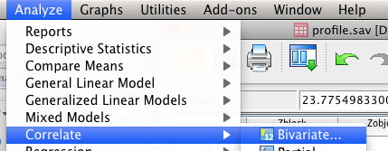

* 1. Move over all your repeated measures variables. Hit ok.

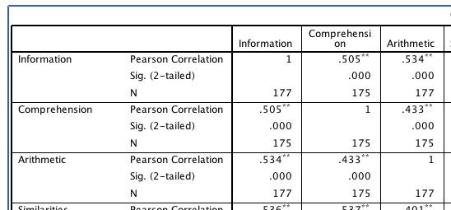

* 1. In the output (small section above) you want to make sure there are not any variables over .9 – if so combine them or only use one of them. If you really love both variables, use them in different analyses.

Univariate Normality

1. You want each individual time measurement to be normally distributed (or at least 30 people).
   1. If you have filled in data from the missing analysis OR eliminated outliers you need to rerun frequencies to get the histograms again.
   2. Analyze > Descriptive Statistics > Frequencies. (see pictures above)
   3. Move over your repeated measures variables.
   4. Hit charts > histograms with normal curve.
   5. Hit ok.
   6. Look at each individual chart. If one looks totally crazy, you can run descriptives and ask for skew/kurtosis values. If they are above or below 3, you might consider transforming your variable.
      1. Analyze > Descriptive Statistics > Frequencies.
      2. Hit statistics.
      3. Click skewness and kurtosis.

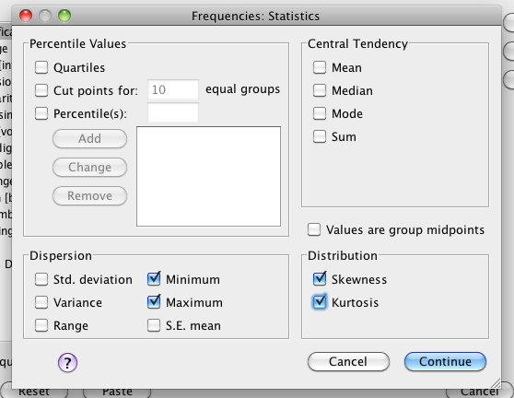

* 1. Check for values above 3 in this box. In this example, it appears we are ok. The histograms also look normal.

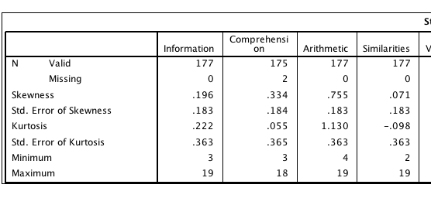

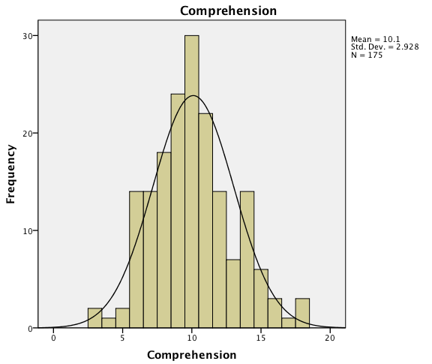

Multivariate Normality

1. To get multivariate normality, you have to run a fake regression. If you have change ANYTHING in the previous steps, rerun your regression from the outlier check (see pictures above).
   1. Analyze > regression > linear.
   2. Put the random variable in the dependent box.
   3. Put your repeated measures variables in the independent box.
   4. Hit plots.
   5. Zpred in Y, Zresid in X. Check the boxes for histogram and normal probability plot.
   6. Look for this figure: You want it to look moderately normal. (I did not eliminate outliers or fill in data in my example here).

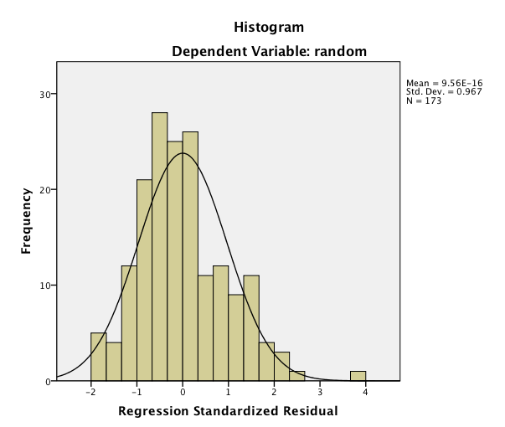

Linearity

1. Linearity can be found in the same analysis as above for normality. You want to look for the Normal PP Plot. Make sure the dots are close to the line. You do not want big bends in the dots or a big curve away from the line.
2. Our example here looks good.

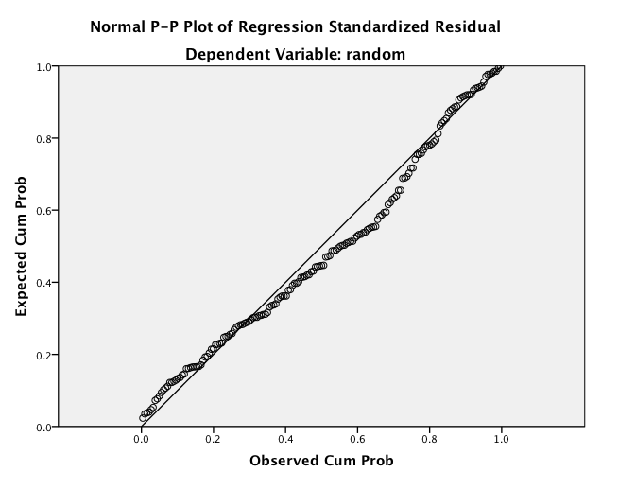

Homogeneity

1. Homogeneity can also be checked with the fake regression analysis. You can use Box’s M and Levene’s for these analyses as well, but this visual will help check if there’s anything to worry about.
2. Look for the Residual Plot.
   1. Draw a line at zero.
   2. Is the spread of the dots the same above and below zero?
   3. Here it’s not totally even. One side goes to 4, while the other goes to 2. The spread is approximately the same, but there might be some univariate outliers.
   4. We should also check Box’s and Levene’s to make sure they are not p<.001.

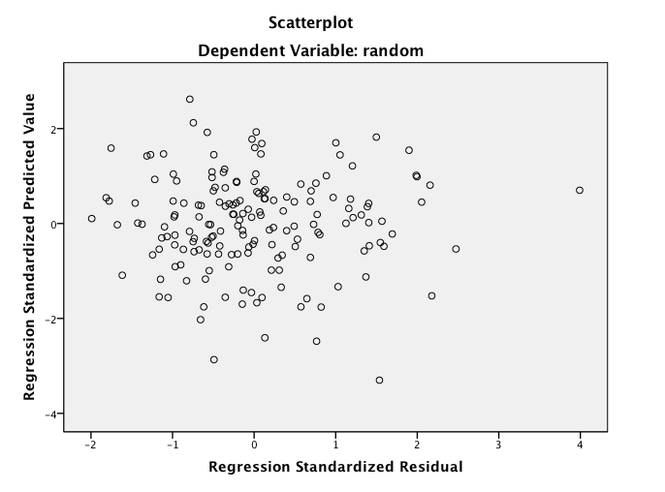

Running the Profile Analysis.

1. Be sure to distinguish between your between subjects and repeated measures variables.
2. Analyze > General Linear Model > Repeated measures (remember any time you have repeated measures variables, you run it as RM).

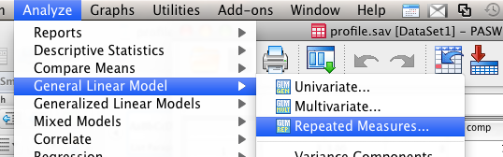

1. Label your repeated measures variable with something you will recognize. In the number of levels box – put how many repeated measures “time measures” you have. You can label several repeated measures variables here, but in this case, we have only one.

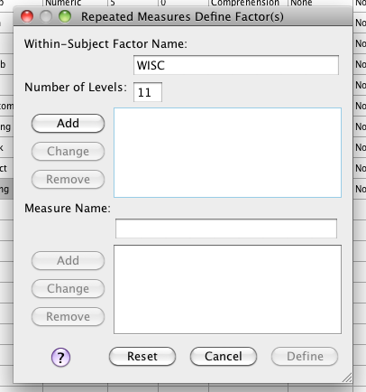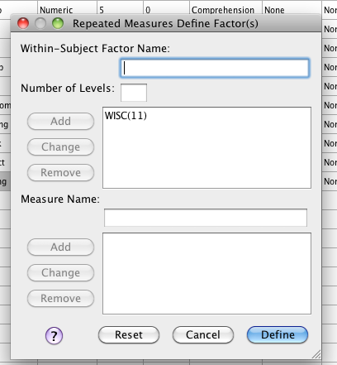

1. Be sure to hit add, then define.
2. You will want to move over your time measurements into the slots for the WISC (where it says within subjects variables).
3. Move your “agemate” variable into the between subjects box.

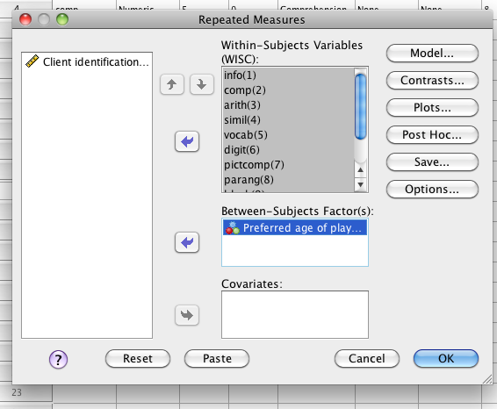

1. Hit post hoc to get post hoc tests for the main effect of playmate. Move the factor over to the right, and click Tukey (or bonferroni or scheffe for a lot of tests).
2. Hit options. Move the means over to the right. Ask for descriptive statistics, effect size (for eta squared), and homogeneity (Levene’s). Hit continue and ok.

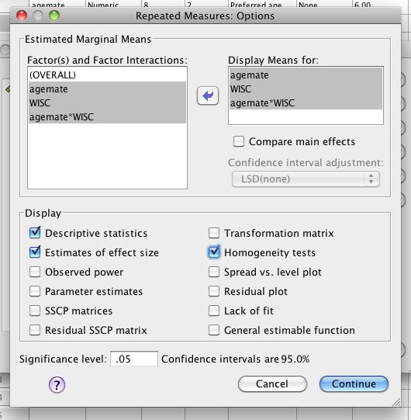

Translating the output:

1. The first boxes in the output are useful, but not important for the analysis. SPSS reminds you of the variables you picked for the repeated measures factor (usually labeled “measure_1” and then the number of people in each condition for the between subjects factor.

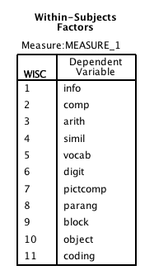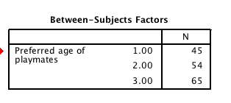

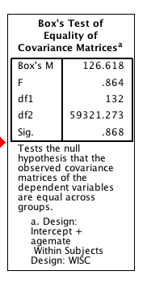

1. The next box is a set of descriptive statistics for the interaction (especially useful if you want to use SDs instead of SEs).
2. Box’s M – Box’s is another test of Multivariate Homogeneity. You *want* p>.001. You *do not want* p<.001. If it is significant AND you have a small sample (N<30), you are better off doing a non-parametric test.
   1. Here our homogeneity is ok because p=.87.
3. Multivariate test box: This part of the output is the important part!
   1. It should look similar to a MANOVA box, which gives you the different combinations of the DV to create the greatest differences across groups. Here it gives you the DV combinations that create the greatest time segment differences (or the slopes between time measurements).

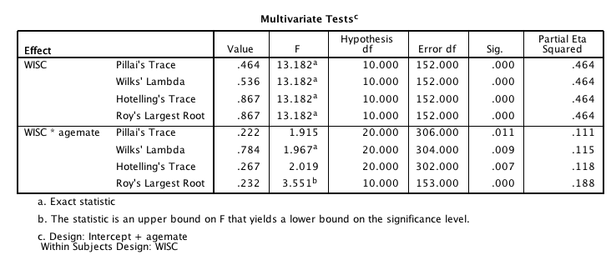

1. **Flatness**: Flatness is in the multivariate tests box, and it’s going to be the variable that you labeled as your repeated measures variable. This example it’s the WISC variable.
   1. The most common multivariate test to use is Wilk’s Lambda. It’s the most tested and stable of the multivariate tests.
   2. Hypothesis df = first df or groups degrees of freedom (time measurements – 1).
   3. Error df = second df, or people – (groups).
   4. Sig = p-value.
   5. Reporting:
      1. We found a significant effect of flatness, *F*(10, 152) = 13.18, *p*<.001, n2 = .46, which indicates that there are different scores on the different subscales of the WISC (aka time measurements are NOT the same).
2. **Parallelism:** Parallelism is in the multivariate box as well – because it’s an interaction with the repeated measures variable. You look in the same places as the Flatness profile, but in the next box down.
   1. Reporting (note: this normally goes AFTER the Levels statement, just talking about it here because we are looking at the output box).
      1. We found a significant effect of parallelism, *F*(20, 304) = 1.97, *p*=.01, n2 = .12.
3. **Sphericity**: This box is actually about assumptions – it’s AFTER the multivariate box because you cannot ever meet the multivariate Sphericity assumption. Here you *do not* want p<.001. However, if you are running this as a profile analysis, you basically ignore Sphericity because you are using the multivariate version.

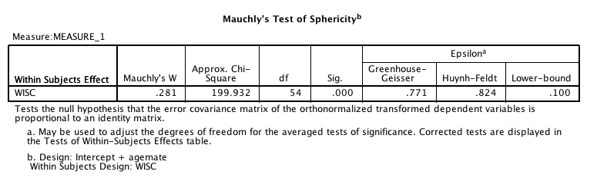

1. The boxes on **within subjects effects and within subjects contrasts** – depending on which tests are significant (flatness, parallelism, levels) you may or may not need this box. We are going to ignore both of them for right now.
2. **Levene’s**: Levene’s is actually a test for univariate homogeneity. You checked for multivariate homogeneity with Box’s M. If you have p<.001, you might be able to figure out which variable is the problem with Levene’s. Then you can decide to exclude that “time measurement” (depending on research question) or average two time segments or run the tests separately. This box would be especially useful in cases of small sample sizes and homogeneity issues. Here, all values are p>.001, which means we’ve meet the assumption.

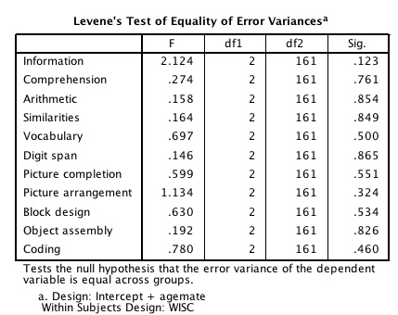

1. **Levels:** Levels is the test of the between subjects variables overall. It will be in a between subjects box, after many boxes about repeated measures. You read this box exactly as you would a regular ANOVA box (because it is!).
   1. 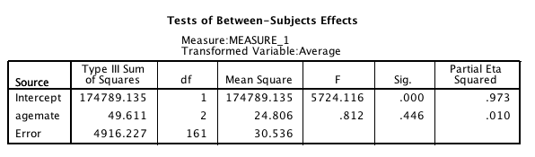Reporting**:**
      1. We did not find a significant effect of levels, which indicated that playmate choice did not have an effect on WISC profiles, *F*(2, 161) = .81, *p*=.45, n2 = .01.
2. **Descriptive Statistics:** The following three boxes will give you the means for levels, flatness, and parallelism. You may or may not use them depending on the significant effects for the profile analysis.

**LEVELS MEANS AND STANDARD ERROR**

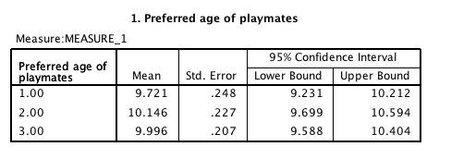

**FLATNESS MEANS AND STANDARD ERROR**

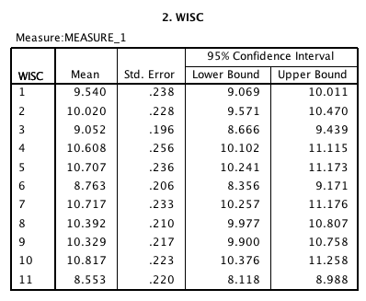

**PARALLELISM MEANS AND STANDARD ERORR (only copied part of the chart):**

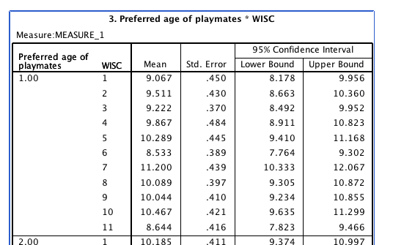

Post Hoc Analyses Flow Charts:

* Levels (between subjects) significant effect ONLY.
  + Between subjects ANOVA (already run as part of the Profile)
  + Tukey Post Hoc (or independent t)
  + Means, SD/SE
* Flatness (repeated measures) significant effect ONLY.
  + Multivariate test (already run as part of the profile).
  + Within subjects effects box – Univariate Repeated Measures ANOVA
  + Dependent t-test Post Hoc
  + Means, SD/SE
* Parallelism (interaction) significant effect ONLY.
  + Simple Effects analysis for Levels
  + Simple Effects analysis for Flatness
  + (both described below).
* Parallelism (interaction) AND Flatness (repeated measures)
  + Between Subjects ANOVA for each time measurement
  + Tukey Post Hoc (or independent t)
  + Means, SD/SE
* Parallelism (interaction) AND Levels (between subjects)
  + Repeated measures ANOVA for each group separately
  + Dependent t-test Post Hoc
  + Means, SD/SE
* Parallelism (interaction), Levels (between subjects), AND
  + Simple Effects analysis for Levels
  + Simple Effects analysis for Flatness
  + Mixed Design ANOVA for a small section of the data
    - Post Hoc will be either dependent t OR Tukey/independent t
    - Means, SD/SE

The following pages will cover Simple Effects analyses. For Levels only – go back and look at between subjects ANOVA chapter. For Flatness only – go back and look at repeated measures only chapter. If you wish to do a mixed ANOVA on a subset of the data – go back and look at the mixed factorials chapter.

**Simple Effects Analysis (for when parallelism and flatness are significant):**

1. Run a between subjects ANOVA for each time measurement.
2. Analyze > General Linear Model > Univariate

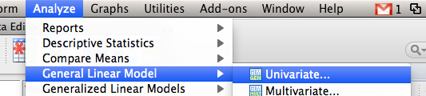

1. Put your first RM measurement into the DV box (in this example, I’m going to test DIGITS). Put your between subjects variable in the IV box.

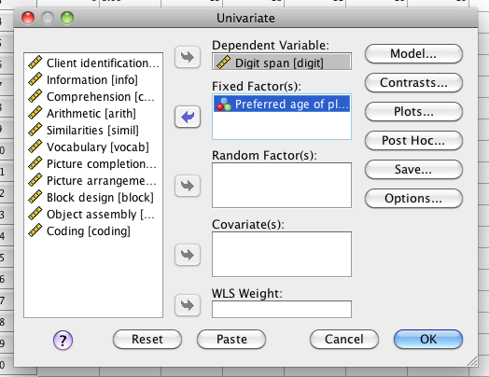

1. Post hoc – move the variable over and ask for Tukey’s Test. Options – move over means, ask for descriptives and effect size (you’ve already checked for homogeneity).

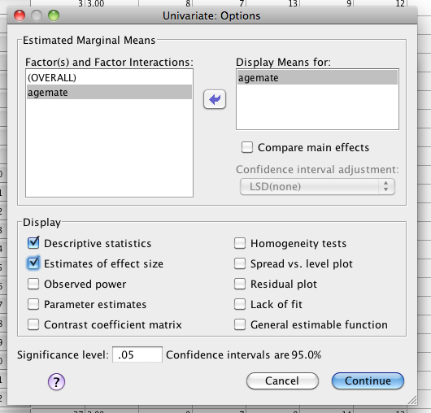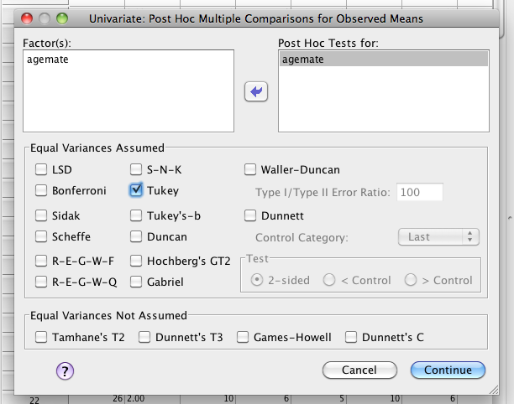

1. Run the analysis. Go to the between subjects box, and look for a significant effect of your between subjects variable.
   1. You have to control for running many tests here, so you will need to create a new F-cut off score.
   2. F critical = (k-1)* F(k-1, k(n-1))
      1. N = number of people
      2. K = number of groups
   3. So here are cut off score is: (3-1) * F critical (3-1, 3(168-1))
      1. 2* F critical (2, 501)
      2. 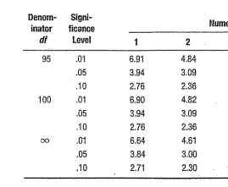
      3. 2 * 3 = 6.
   4. So you will look for values over 6 for your significant effects (see below).
2. 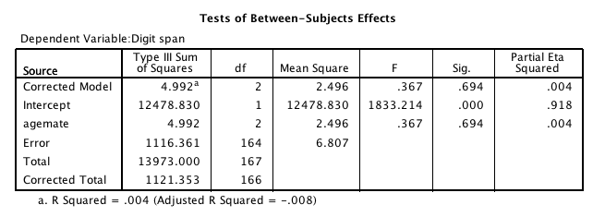You will run between subjects ANOVAs on ALL of the RM measurements.
   1. For any significant effects, then write up the Tukey post hocs as you would for a between subjects ANOVA. Only for the SIGNIFICANT post hoc ANOVAs.

**Simple Effects Analysis (for when parallelism and levels are significant):**

1. You will want to run repeated measures ANOVAs for each group of your between subjects variables.
   1. The easy way to do this is to first split the file and get all groups RM ANOVAs at once.
   2. Data > Split File.

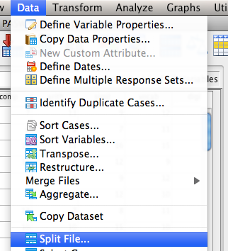

1. Organize output by groups > move your BN variable into the bottom box.

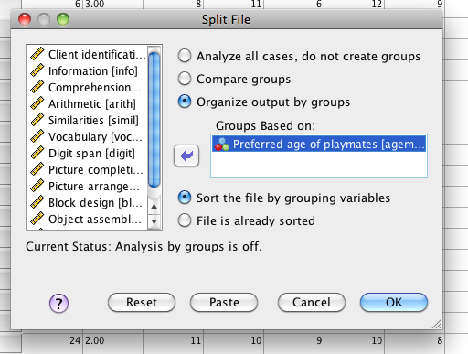

1. Run the analysis. Analyze > General Linear Model > Repeated Measures. (see above).
2. Enter your repeated measure variable the way you did for the profile analysis. Give it a name (WISC here) and how many levels it has and hit add. (also see above).
3. Move the variables over into the slots created for the RM measurements.

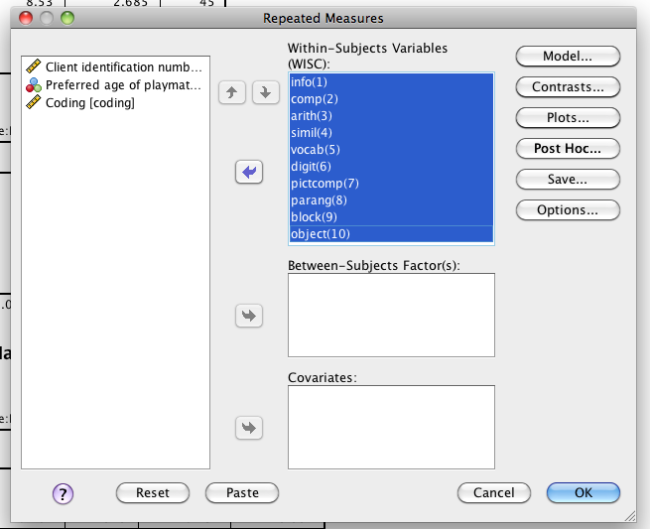

1. Hit options to get means and effect sizes for your groups.

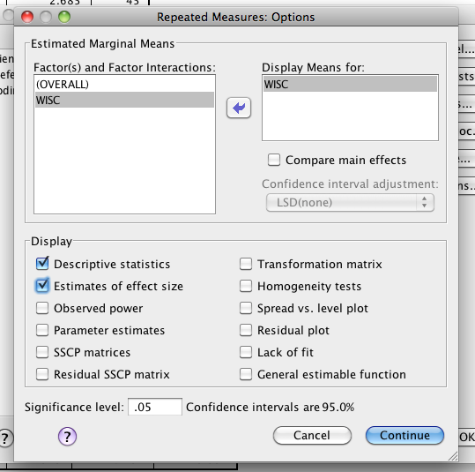

1. In the output, you will look at the Within Subjects ANOVA box. Again you have to control for running so many tests.
   1. Fs = (p-1)*F((p-1), k(p-1)(n-1))
      1. P = number of repeated measures
      2. N = people
      3. K = groups for your between subjects variable
   2. (10-1) * F critical (10-1, 3(10-1)(168-1)
   3. 9 * F critical (9, 4509)
   4. 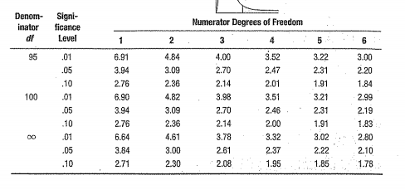
   5. 9 * 2.10 = 18.9

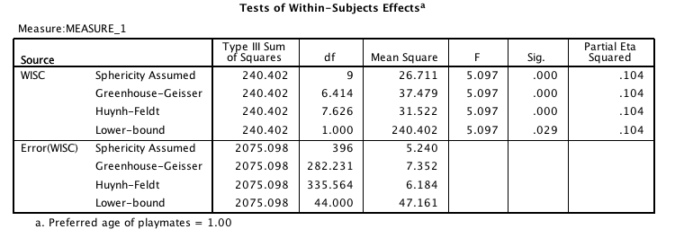

1. Look at a. at the bottom – this tells you what group you are looking at. You want to look at F to see if it passes your critical value.
   1. For F-tests that are significant, you want to run *dependent t-tests* to figure out which RM variables are different from one another.

Write up Example:

Results

The WISC was given to groups of children who had indicated that they preferred younger, older or same age playmates. This data was screened for missing data, which was replaced with a linear trend at point. Several univariate outliers were present, but none were eliminated because they were not found to be multivariate outliers using Mahalanobis distance. Data were found to be normally distributed, linear, and homogeneity assumptions were met (Box’s M *p*=.87).

A profile analysis was used to examine the interaction between WISC profiles and preferred age of playmate. We found a significant effect of flatness, *F*(10, 152) = 13.18, *p*<.001, n2 = .46, which indicates that there are different scores on the different subscales of the WISC. We did not find a significant effect of levels, which indicated that playmate choice did not have an effect on WISC profiles, *F*(2, 161) = .81, *p*=.45, n2 = .01. However, there was a significant effect of parallelism, *F*(20, 304) = 1.97, *p*=.01, n2 = .12, and this interaction will be examined using a simple effects analysis.

Repeated measures ANOVAs were run using each subscale of the WISC and the preferred age of playmate as the independent variable. Scheffe *F* corrections were used to control for the Type I error rate, *F*critical = 6.00. Preferred age of playmate did not have a significant effect on digit span, *F*(2, 164)=.37. (*here you would talk about each one and their significance, the next test is NOT significant, but pretend so you can see how it’s written).* Preferred playmate did have a significant effect on vocabulary, *F*(2, 165) = 7.88, n2 = .45. Tukey post hoc tests indicated that younger preferred playmates had lower vocabulary scores (*M*=12.25, *SE*=1.25) than older preferred playmates (*M*=15.78, *SE*=1.39), *p*=.03. No significant difference was found between younger playmates and same age playmates (*M*=14.20, *SE*=1.23), *p*=.70, or older playmates and same age playmates, *p*=.45.